**LoreTrail : UI/UX Case Study**

**LINKS:**

* + PROTOTYPE : <https://www.figma.com/proto/nJLLyCCOPHjye9t0WzNKcb/Designora--LoreTrail?node-id=3-13&t=c0D2Ygk7YFMwSPqh-0&scaling=contain&content-scaling=fixed&page-id=0%3A1&starting-point-node-id=3%3A13&show-proto-sidebar=1>
  + FIGMA FILE : <https://www.figma.com/design/nJLLyCCOPHjye9t0WzNKcb/Designora--LoreTrail?node-id=3-13&t=c0D2Ygk7YFMwSPqh-1>

**PROBLEM STATEMENT :** Folklore, mythology, and fantasy stories are deeply rooted in culture but are slowly disappearing in the digital age. Existing platforms like Wattpad or Reddit focus broadly on storytelling but also lack engaging UI . As a result, younger audiences are disconnected from stories, and creators struggle to showcase them in an engaging format.

**SOLUTION** : LoreTrail is a digital storytelling platform designed folklore and mythology and short story lovers. It allows users to discover, create, and share stories in an immersive, community-driven way. By combining intuitive design with interactive features, LoreTrail bridges the gap between cultural heritage and modern digital engagement.

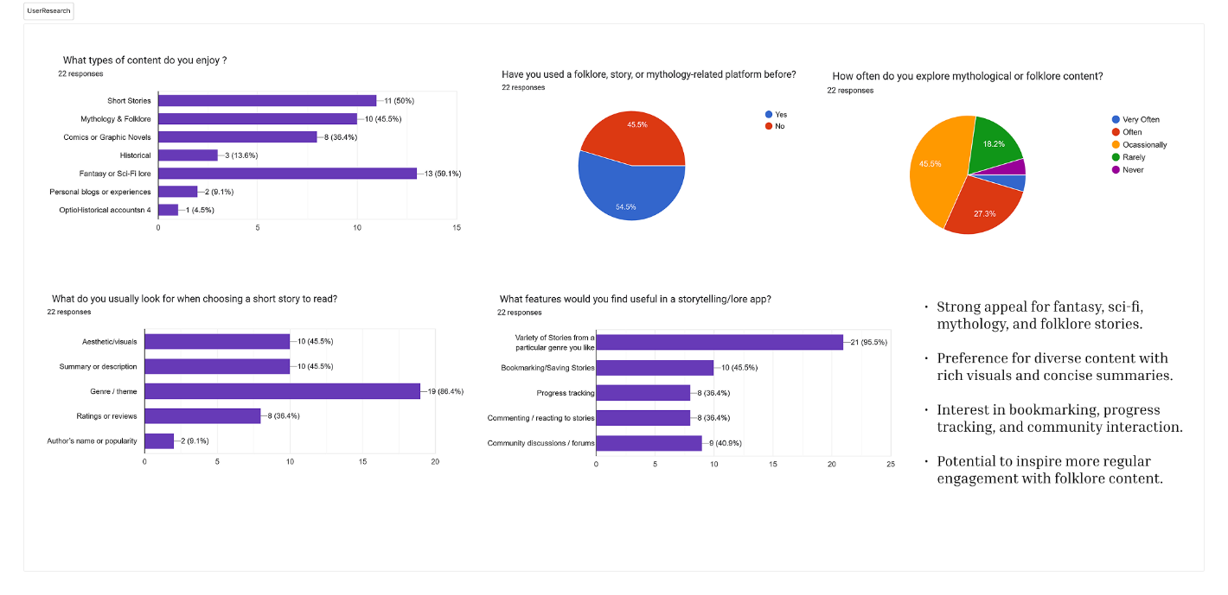**USER RESEARCH**

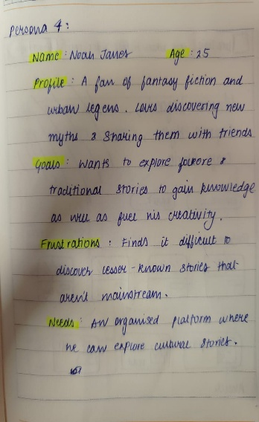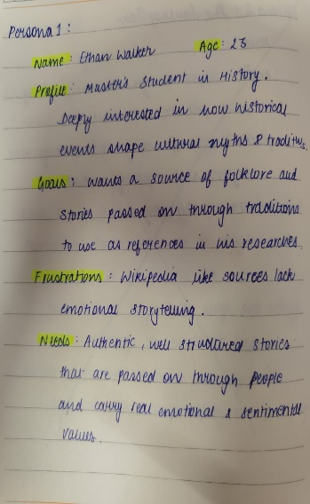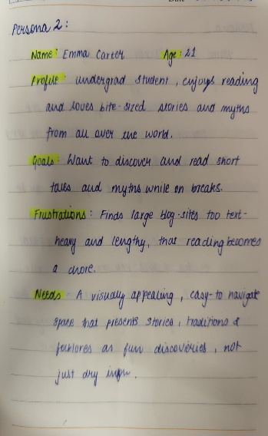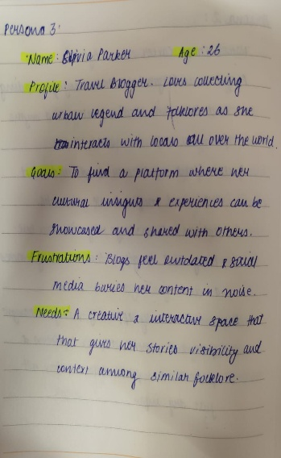**USER PERSONA**

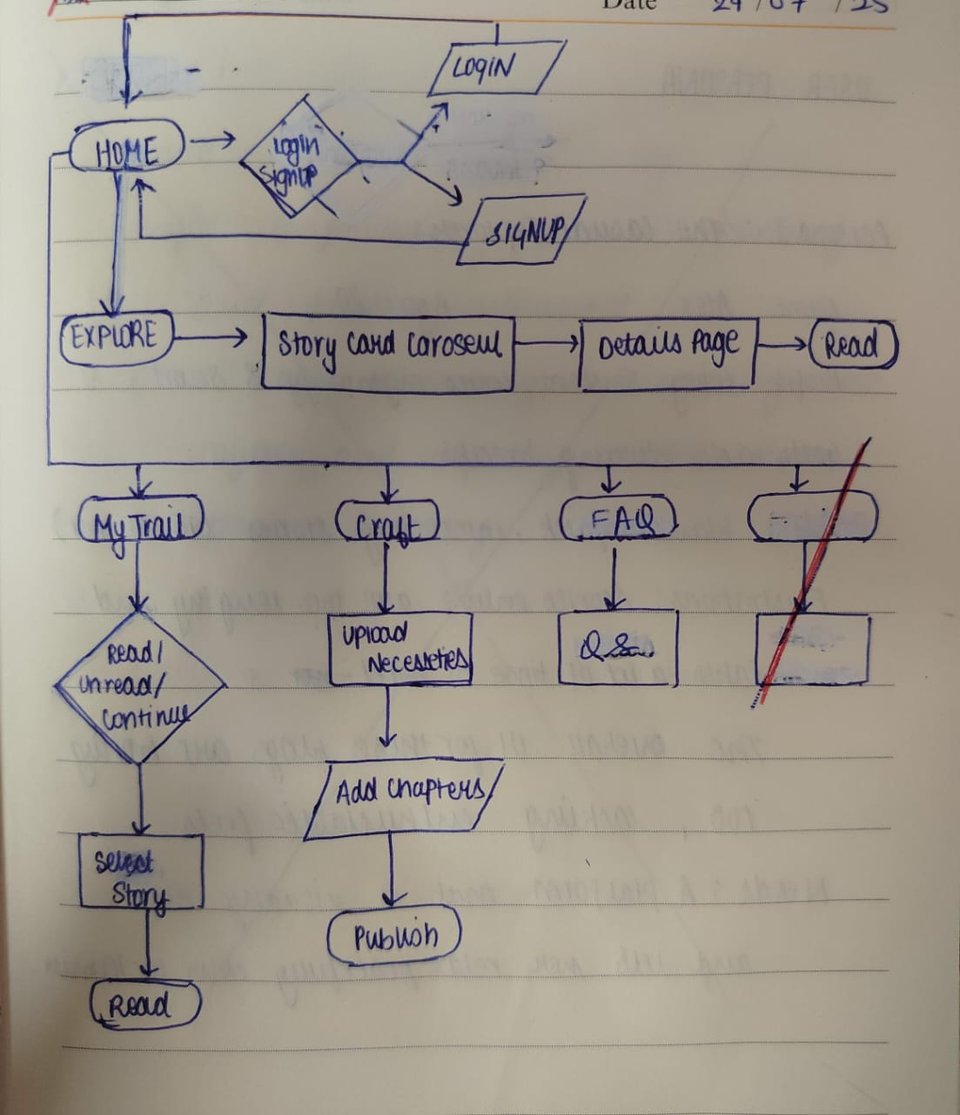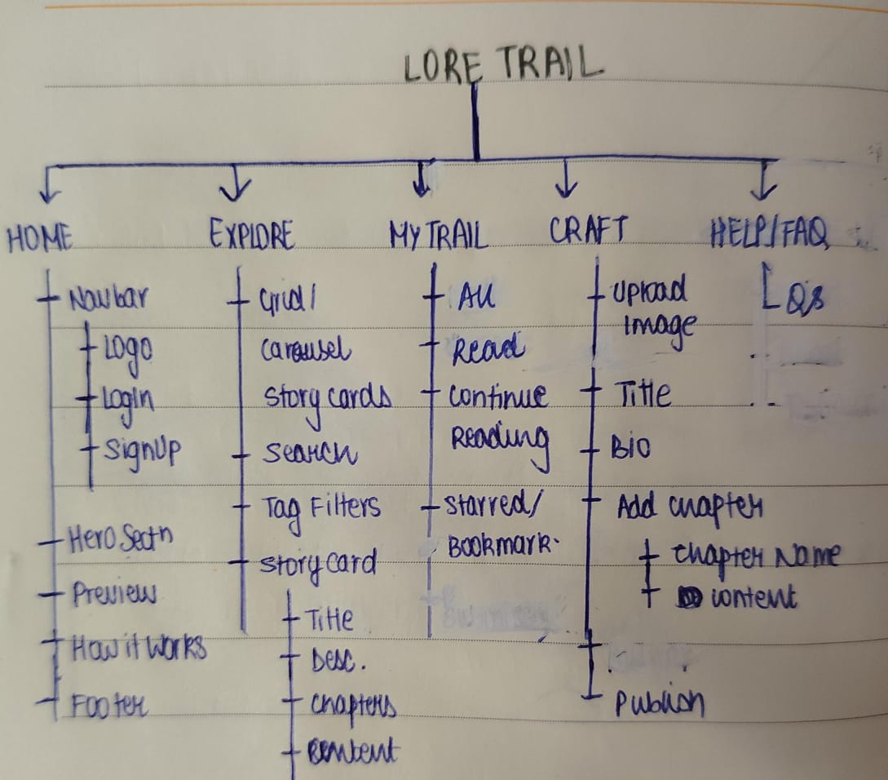**SITE MAP USER FLOW**

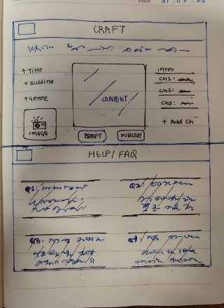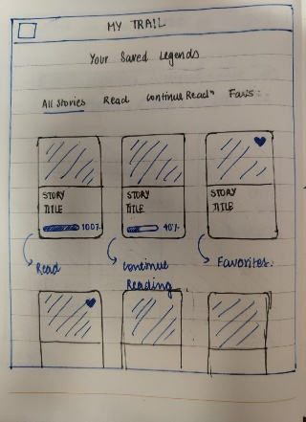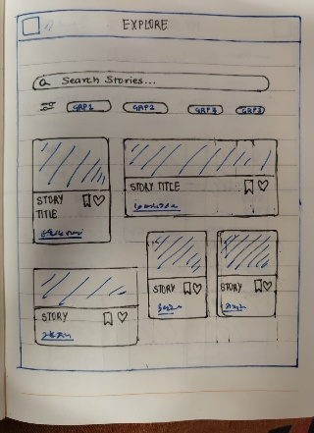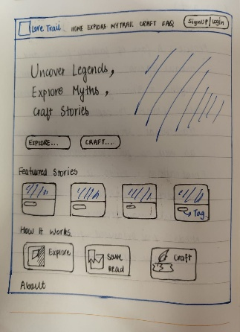**WIREFRAME**

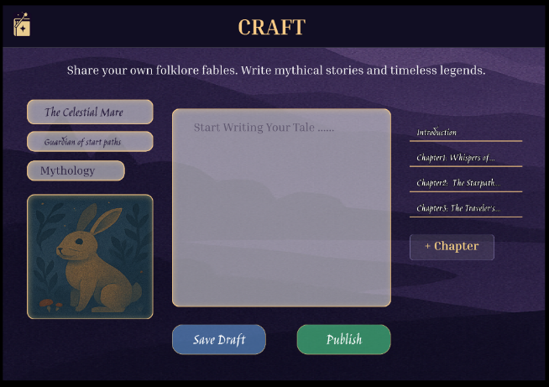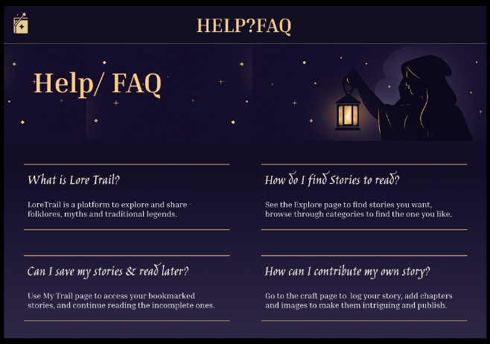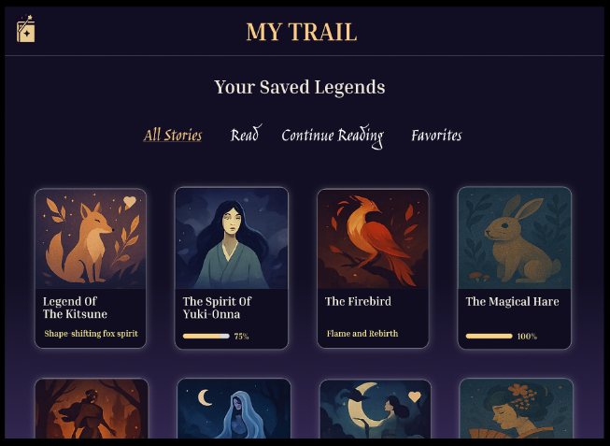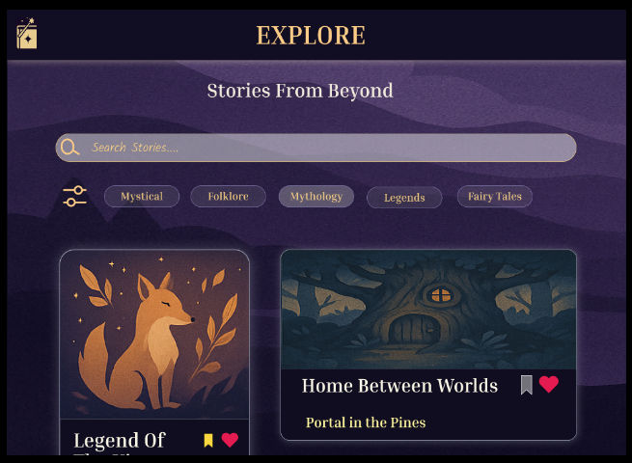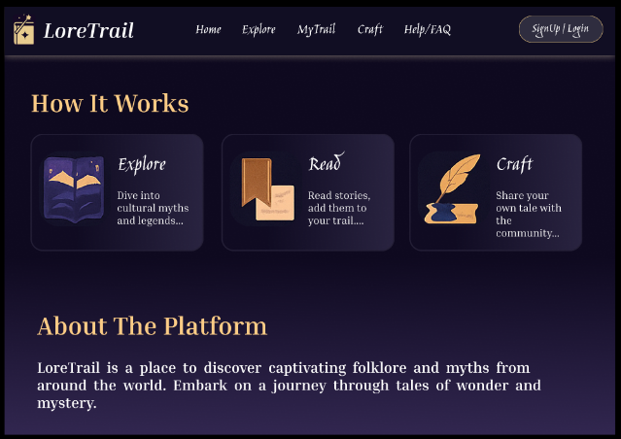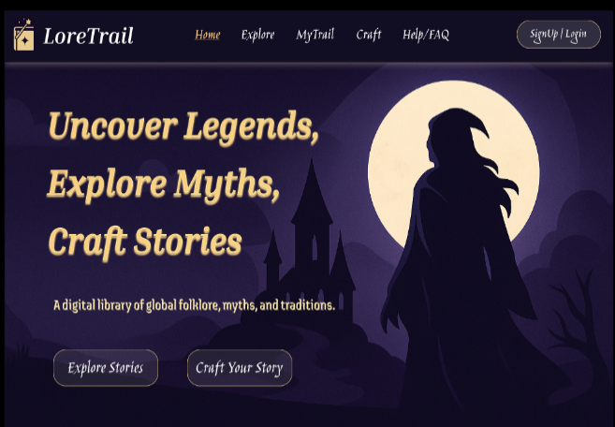**PROTOTYPING**

**USABILITY TESTING**

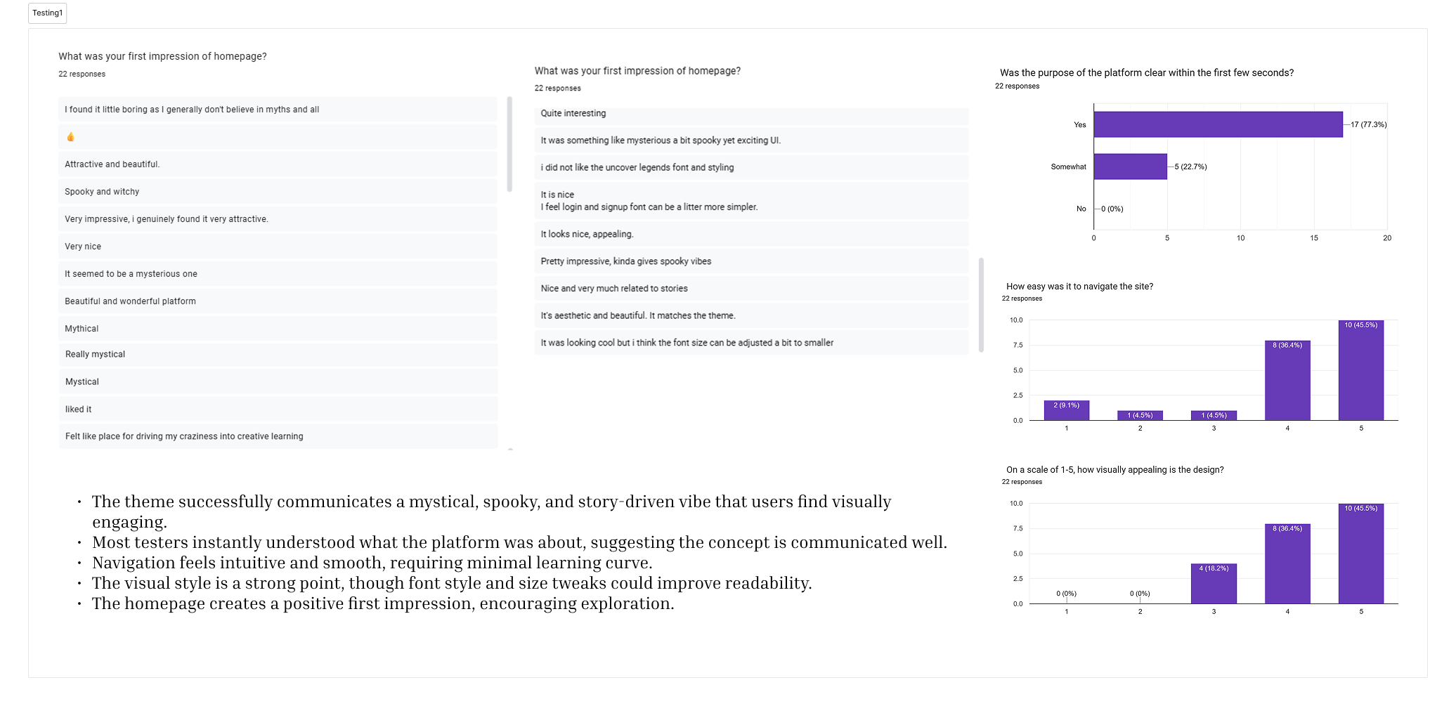

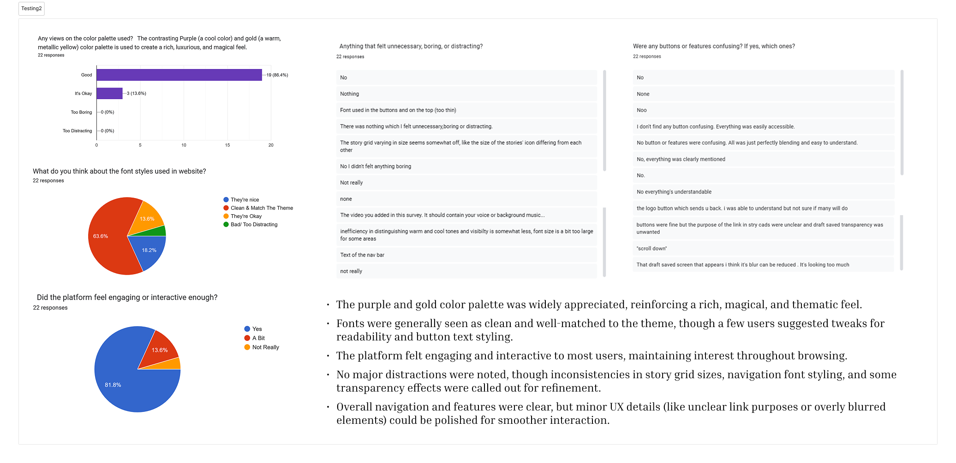

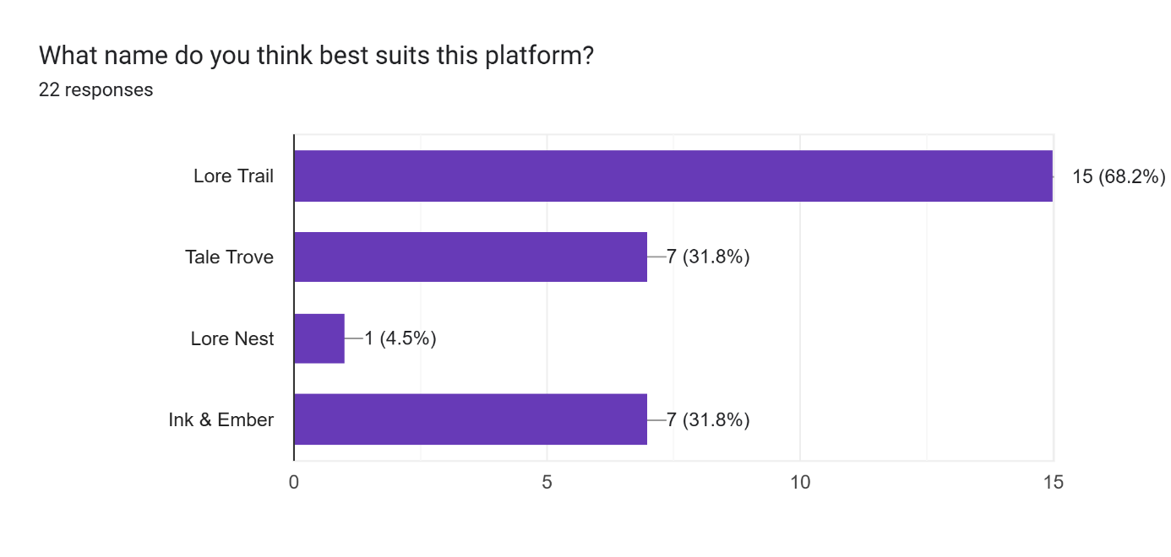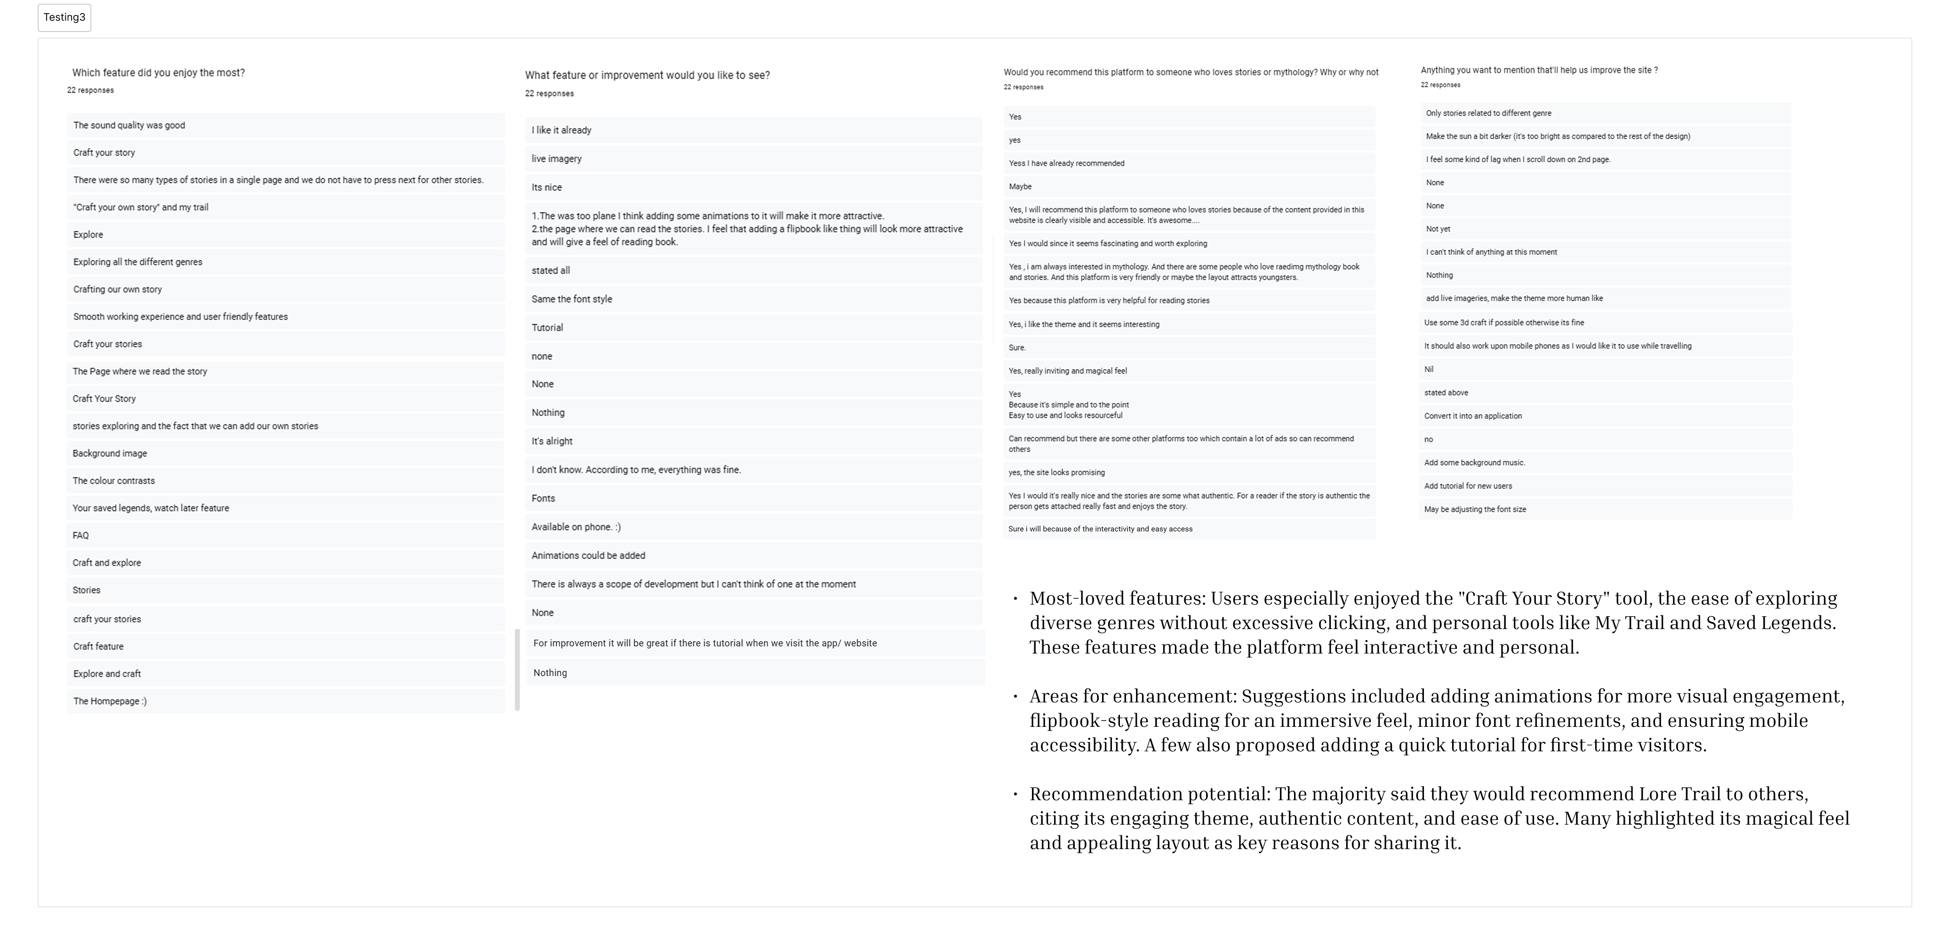

**VAIBHAVI SRIVASTAVA**